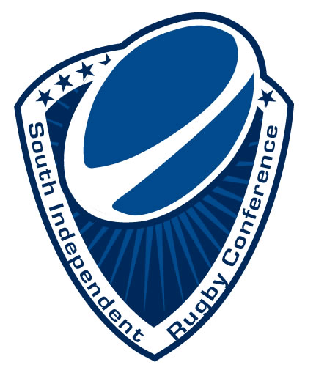
South Independent Rugby Conference
A USA Rugby Collegiate Division I Conference

Membership Agreement

This agreement between the applicant and the South Independent Rugby Conference
(SIRC) sets forth the terms of the applying team’s membership in the South Independent
Rugby Conference.

Applicant agrees to comply with all policies related to competition, eligibility and membership that may now exist or may be approved by a vote of the conference membership in the future. Additionally, applicant/team agrees to abide by procedures that may be proclaimed by the conference related to codes of conduct, game day practices and general administrative directives.

Use of Logos and Images
The applying team will provide SIRC with a team logo. The applicant grants the right to use the team name, trademarks and logos, and the names, voices, images and likenesses of the team members in connection with the advertising, promotion, marketing, selling, broadcast and distribution of the conference in any manner and in any and all formats or media or markets whatsoever. This is understood to include only those marks and logos that are held by the team and does not include those marks or logos held exclusively by the University and/or athletic department.

By signing below, I hereby certify that I have the authority and right to request membership in the South Independent Rugby Conference.

_________________________________________________ _______________
Student Leadership Representative Date

_________________________________________________ _______________
Non-student Leadership Representative Date

_________________________________________________ _______________
University Representative Date

